Procedure for I/O block config on ARSAW

You will need a program that I have put a copy on the shared drive called Turck Service Tool. This lets you see the I/P addresses of the 2 masters (11.200.1.130) for the front of the machine located on the left side of the VRC and visible thru the glass and on the back side of the machine along the top conveyor and it is the first I/O block, visible from the right hand side of the machine (11.200.1.170) every other block is a slave to it’s respective master.

This is a screenshot using the Turck service tool of the config you should see and if you need to pinpoint an I/O block you can use the blink tool and it will flash a light on the I/O block. On the bottom side of the block is the MAC address which you will see in this tool. Only the masters get an IP address and you can click on change to give the master its IP address. The subnet is 255.255.255.0 and the gateway is set to 0.0.0.0.

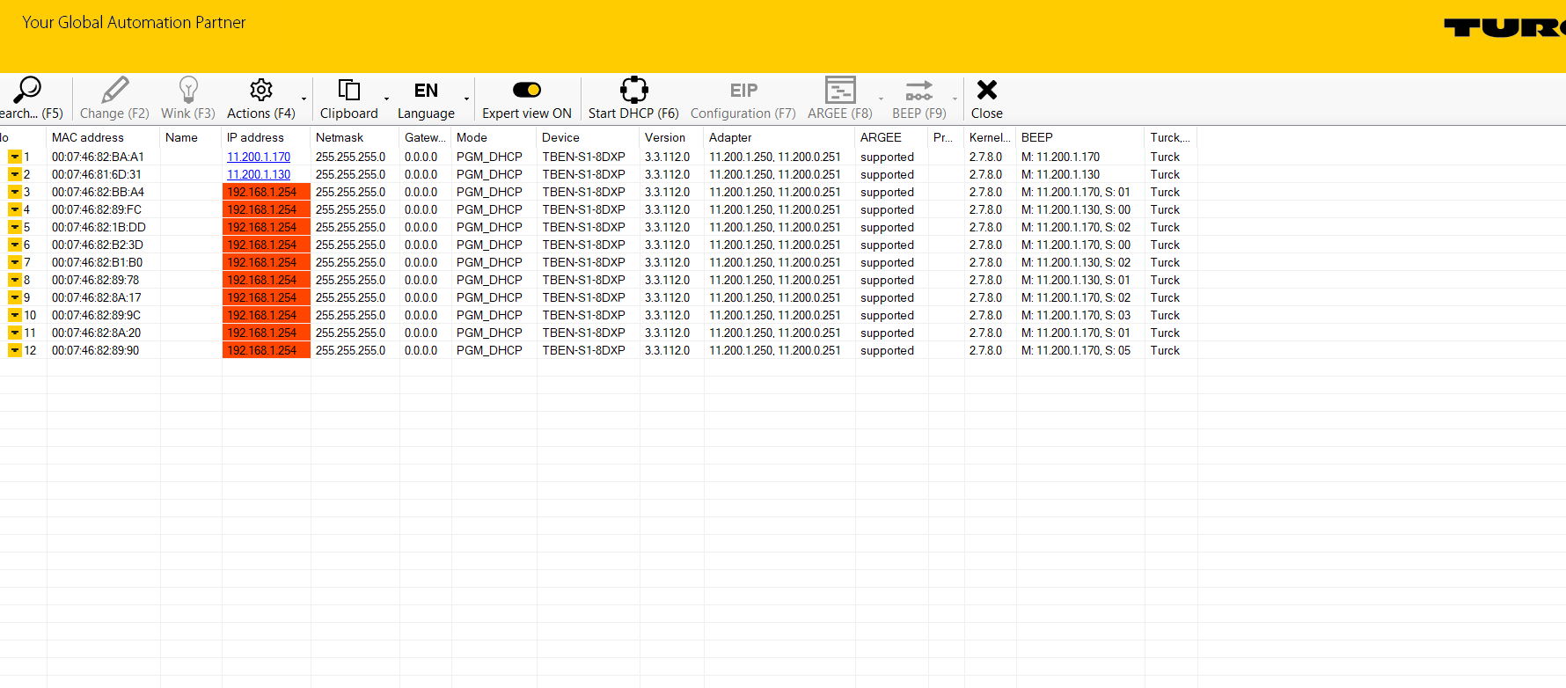

Once you have the master’s IP address set you can get out of this program and now using a browser log into the I/O block, which you can see on the next screen:

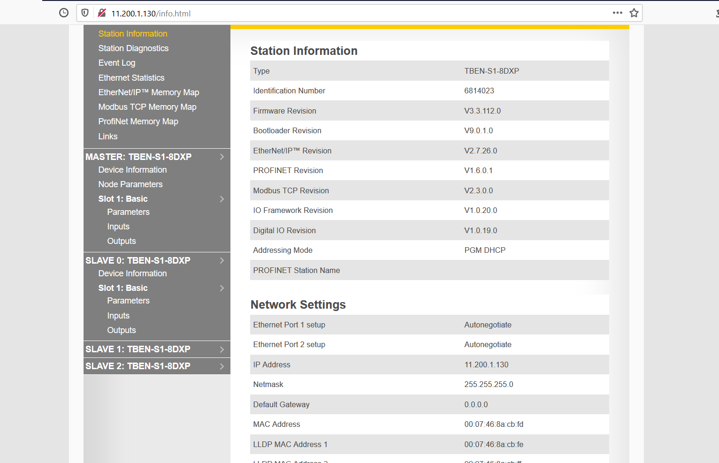

On the next screen I show you what it looks like logged in after entering the password and the password is: password.

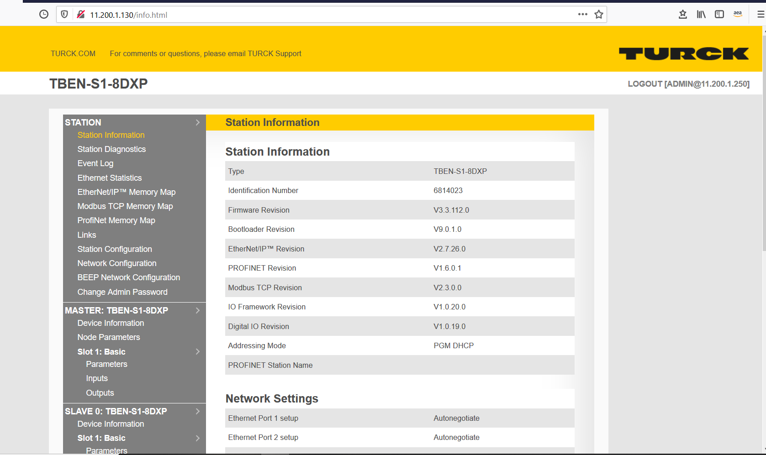
So what you should see is a master and then on the 130 address 3 slaves 0 thru 2. On 170 address you should see one master and 7 slaves shown here:
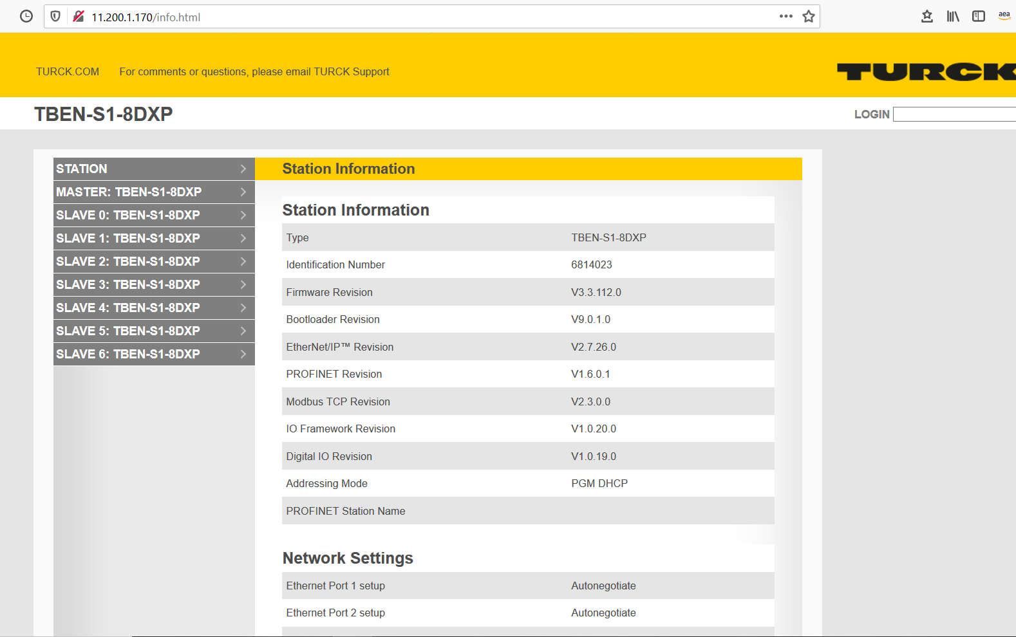
If you do not see a master and or slaves then you need to click on BEEP network configuration and you then enable the master and then click on discover/update network and it should then populate with the number of slaves attached to the master, as shown in the screen here:
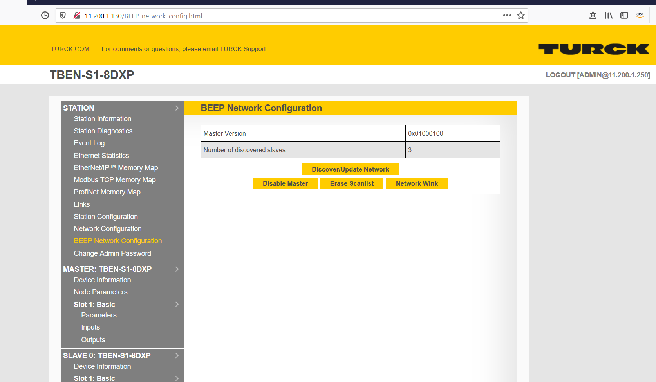
At this point everything should now be talking just fine. I have also put the Turck manuals in a folder on the shared drive under controls.

